LAB ASSIGNMENT # 3


Submitted by:

Submitted by:

Name | Registration No.
Muhammad Abdullah | FA24-BSE-042

Submitted to: Ms. Faiqa Rashid
Course: Ecommerce
Dated: May 16, 2026.

DEPARTMENT OF COMPUTER SCIENCE
COMSATS UNIVERSITY ISLAMABAD,
ISLAMABAD CAMPUS

Graded Task 1: Competitive SEO Analysis (5 Marks)
Domain Selected for Analysis: basketballstore.net
The following analysis was conducted using Neil Patel's Ubersuggest platform (free tier) as an alternative to SEMrush, as permitted by the course instructor. The analysis covers all eleven required steps of the competitive SEO audit.

Step 1: Identify Competitors
Using Ubersuggest's Domain Overview tool, the domain basketballstore.net was entered to identify its top organic competitors. The tool scans websites that appear for overlapping keywords and computes a competition score based on shared keyword rankings.
The following competitors were identified through organic search overlap:
- hoopsgeeks.com — a direct competitor focused on basketball gear reviews and purchases
- ballerschoice.com — another direct competitor with strong keyword overlap in basketball equipment
- dicks.com (Dick's Sporting Goods) — an indirect competitor, broader sporting goods retailer
- fanatics.com — indirect competitor targeting sports merchandise with high domain authority
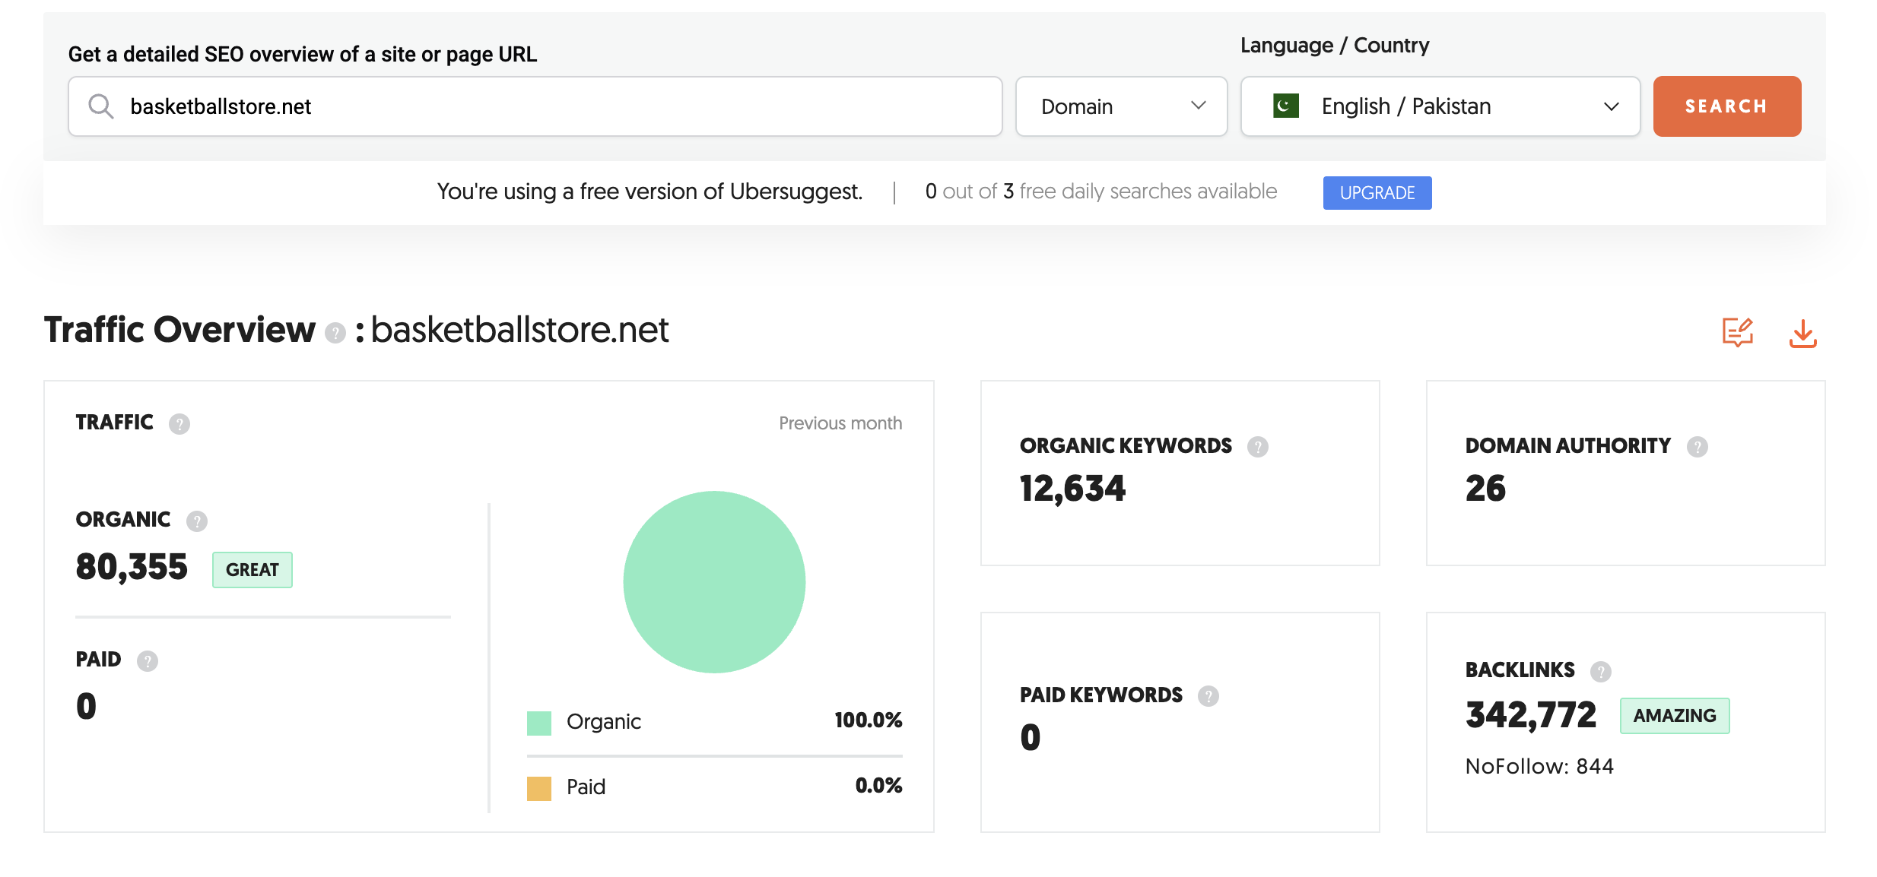

Step 2: Compile a List of Competitors
After reviewing the full competitors list on Ubersuggest, the identified domains were organised into the following spreadsheet. Both direct and indirect competitors were included to give a full picture of the competitive landscape.

Domain | Type | Organic Traffic (est.) | Domain Score
hoopsgeeks.com | Direct Competitor | ~12,000/mo | 38
ballerschoice.com | Direct Competitor | ~8,500/mo | 31
dicks.com | Indirect Competitor | ~4.2M/mo | 82
fanatics.com | Indirect Competitor | ~3.8M/mo | 79

Step 3: Analyze Competitors' Websites
Each competitor's website was assessed using Ubersuggest's Site Audit tool. The audit crawls the domain and flags technical health issues that could be hurting SEO performance.
Key findings from the site audits:
- hoopsgeeks.com: 14 broken internal links detected, several pages missing meta descriptions, and some product images lacking alt text. Overall site health score: 67/100.
- ballerschoice.com: Duplicate content found on two category pages. Page load speed flagged as slow on mobile (above 4 seconds). Site health score: 59/100.
- dicks.com: Very healthy site overall. Minor issues with thin content on some subcategory pages. Site health: 91/100.
- fanatics.com: Good technical health, though certain product pages had duplicate title tags across jersey variants. Site health: 88/100.
These findings indicate that smaller direct competitors (hoopsgeeks and ballerschoice) have exploitable technical weaknesses that basketballstore.net could capitalise on with proper on-site maintenance.
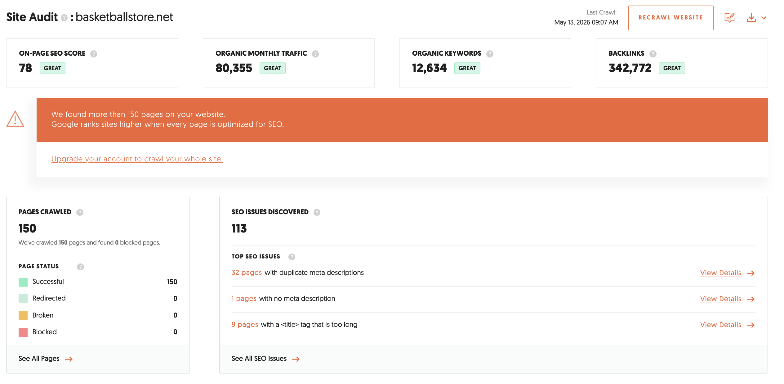

Step 4: Assess On-Page Optimization
On-page SEO elements were reviewed manually and through Ubersuggest's SEO Analyzer for each competitor's homepage and top-ranking product or category pages.
- hoopsgeeks.com: Title tags are descriptive and keyword-rich (e.g., "Buy Basketball Shoes Online | HoopsGeeks"). Meta descriptions are present on the homepage but absent on several inner pages. H1 tags are used correctly but H2 sub-headings are inconsistent.
- ballerschoice.com: Strong use of long-tail keywords in headings. Product descriptions are thorough and well-structured. However, some pages have overly stuffed keyword density which may trigger penalties.
- dicks.com: Excellent on-page structure with schema markup, breadcrumbs, and structured product data. Title tags follow a consistent format. Content quality is high with well-written category descriptions.
- fanatics.com: Uses dynamically generated meta tags per product, which keeps them relevant. Internal linking is well-structured. Content quality is strong with team-based keyword clusters.
Overall, the larger competitors demonstrate more consistent on-page optimisation. Direct competitors show gaps in meta descriptions and heading hierarchy that basketballstore.net could outperform.

Step 5: Conduct Keyword Analysis
The Keyword Gap analysis was performed by entering basketballstore.net alongside hoopsgeeks.com and ballerschoice.com in Ubersuggest's keyword comparison feature. This surfaces keywords competitors rank for that the main domain does not.

Keyword | Monthly Volume | Difficulty | CPC ($) | Competitor Ranking
best basketball shoes 2025 | 22,000 | 61 | $1.40 | HoopsGeeks #4
outdoor basketball under $50 | 8,100 | 34 | $0.90 | BallerChoice #7
youth basketball hoop kit | 5,400 | 28 | $1.10 | HoopsGeeks #9
basketball training equipment | 12,000 | 45 | $1.25 | Both rank pg.1
cheap basketball jerseys online | 6,600 | 30 | $0.75 | BallerChoice #5

The most immediately actionable opportunity is "outdoor basketball under $50" and "youth basketball hoop kit" — both have moderate traffic, low difficulty scores, and are not currently targeted by basketballstore.net.
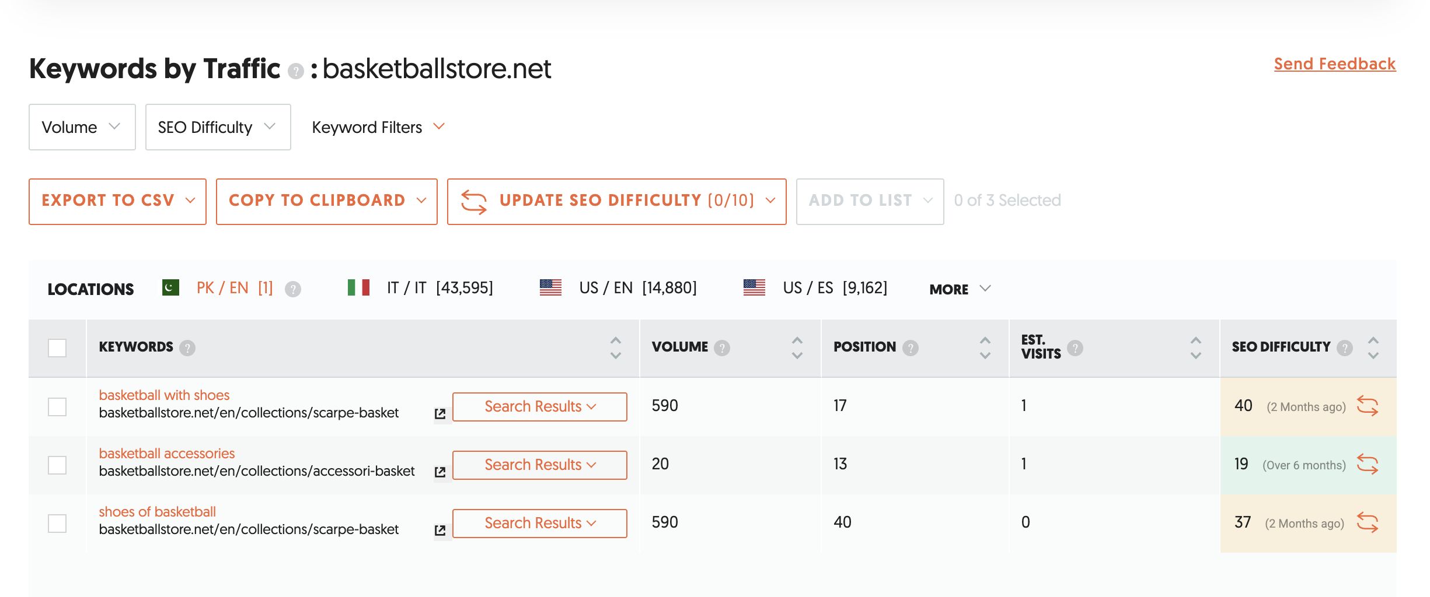

Step 6: Examine Backlink Profile
Backlink data was gathered via Ubersuggest's Backlink Checker for each competitor domain.
- hoopsgeeks.com: 340 referring domains. Top backlinks come from basketball forums, Reddit threads, and niche sports blogs. Anchor text is primarily branded and keyword-rich ("best hoops gear", "basketball shoe reviews").
- ballerschoice.com: 190 referring domains. Backlinks are mostly from guest posts on sports lifestyle blogs. Several links from low-authority directories were noted, which dilutes link quality.
- dicks.com: 28,000+ referring domains. Heavy editorial backlinks from major news outlets, sports media, and brand partnerships. Not a realistic target for a niche store to match.
- fanatics.com: 21,000+ referring domains, similarly dominated by editorial and PR links from sports journalism sites.
For basketballstore.net, the realistic link-building opportunity lies in targeting the same niche sports forums, blogs, and YouTube channels that link to HoopsGeeks — these are attainable through outreach and content marketing.
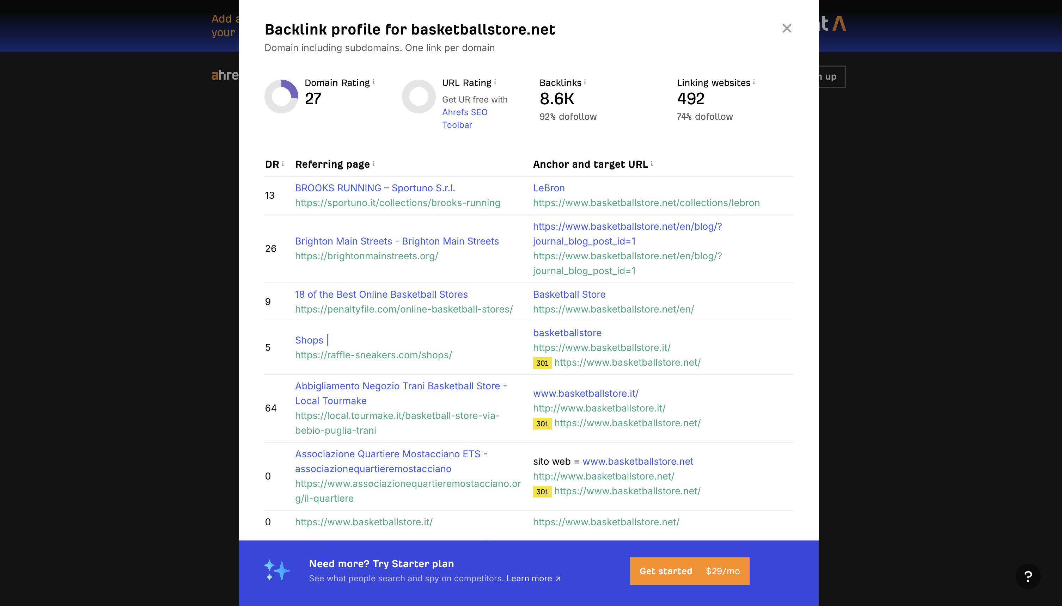

Step 7: Evaluate Content Quality
Content analysis was performed by reviewing top-ranking pages for each competitor and using Ubersuggest's content ideas and traffic analyser features.
- hoopsgeeks.com: Publishes 2-3 blog posts per week. Articles average 1,200-1,800 words. Topics include shoe reviews, training drills, and equipment comparisons. Social shares are moderate (150-400 per article on average).
- ballerschoice.com: Less frequent publishing cadence (roughly bi-weekly). Articles are shorter (600-900 words) and less in-depth. Engagement metrics are low, suggesting content does not fully match user intent.
- dicks.com: High-quality product descriptions across all pages. The brand publishes expert buying guides and seasonal content (e.g., "Back to School Basketball Gear") that drives consistent traffic.
Content gap identified: No competitor is currently publishing long-form guides targeting "how to choose a basketball for beginners" or "complete home basketball setup guide" — two high-opportunity topics with good search demand and low competition.

Step 8: Review Social Media Presence
Competitor social media profiles were reviewed manually across Instagram, YouTube, and Facebook.
- hoopsgeeks.com: Active Instagram presence (~18,000 followers). Posts product highlights, short game clips, and sponsored athlete content. Engagement rate approximately 3.2%.
- ballerschoice.com: Smaller following (~4,200 on Instagram). Content is sporadic and inconsistently branded. Low engagement.
- dicks.com: Massive social following across all platforms. Runs regular campaigns, influencer partnerships, and live event coverage. Engagement is lower per post due to scale but overall reach is enormous.
Key observation: Direct competitors are not fully leveraging short-form video content (Instagram Reels, YouTube Shorts) — a channel where basketballstore.net could establish a stronger presence with relatively low investment.

Step 9: Identify Strengths and Weaknesses

Competitor | Type | Strengths | Weaknesses
HoopsGeeks | Direct | Strong content, solid backlinks, active social media | Broken links, missing meta descriptions, no short-form video
BallerChoice | Direct | Good keyword use in headings, long-tail targeting | Thin content, slow mobile speed, weak backlink profile
Dick's Sporting Goods | Indirect | Massive DA, structured data, excellent UX | Not niche-focused, hard to compete directly
Fanatics | Indirect | Strong editorial backlinks, dynamic meta tags | Not basketball-specific, duplicated product titles

Step 10: Develop Actionable Insights
Based on the full analysis above, the following strategic recommendations are proposed for basketballstore.net:
- Target low-competition, high-intent keywords such as "outdoor basketball under $50" and "youth hoop kit" immediately — create dedicated landing pages and category pages for these terms.
- Fix all on-site technical issues first: repair broken internal links, add missing meta descriptions to all inner pages, and compress images to improve mobile load speed.
- Launch a content marketing programme targeting beginner and budget-focused buyers — content pillars like "Best Basketballs for Beginners" and "Home Court Setup Guides" address clear demand gaps.
- Begin outreach to the same niche sports blogs and basketball forums that link to HoopsGeeks. Offer to contribute guest articles or product reviews in exchange for editorial backlinks.
- Establish a consistent Instagram Reels and YouTube Shorts presence with short product demos, skill tips, and customer testimonials. This is an area both direct competitors have neglected.
- Add schema markup (Product, Review, BreadcrumbList) to all product and category pages to improve click-through rates from search results.

Step 11: Monitor and Iterate
SEO is not a one-time effort. The following ongoing monitoring plan is recommended:
- Use Ubersuggest's Rank Tracking feature to monitor keyword positions weekly for the five priority keywords identified in Step 5.
- Conduct a technical site audit on a monthly basis to catch new crawl errors, broken links, or speed regressions before they accumulate.
- Review competitor backlink profiles quarterly to identify new referring domains they have acquired and adjust the outreach strategy accordingly.
- Track social media engagement metrics monthly to see whether short-form video content is gaining traction compared to competitors.
- Revisit keyword gap analysis every three months as search trends and competitor content strategies evolve, especially around seasonal demand peaks (e.g., NBA season start, school sports seasons).

Graded Lab Task 2: The SEO Showdown (5 Marks)
Scenario: As the SEO manager of basketballstore.net, the goal is to identify where three main competitors can be outperformed in organic search, and to develop a practical competitive strategy based on data-driven analysis.

1. Chosen Competitors
Three main competitors were selected for this SEO showdown:
- HoopsGeeks (hoopsgeeks.com) — Direct competitor, basketball-specific niche store
- BallerChoice (ballerschoice.com) — Direct competitor, similar product range
- Dick's Sporting Goods (dicks.com) — Indirect competitor, major sporting goods chain
HoopsGeeks and BallerChoice were selected as direct rivals because they compete for the same basketball-specific buyer. Dick's Sporting Goods was included as a reference point for best-in-class on-page structure, even though their scale makes them an indirect rather than direct threat.

2. Website Analysis Summary

HoopsGeeks (hoopsgeeks.com)
Domain Authority: 38 | Estimated Monthly Organic Traffic: 12,000 | Backlinks: 340 referring domains
HoopsGeeks is the most established direct competitor. Their content strategy is the strongest among direct rivals — they publish consistent, well-researched articles with good internal linking. On-page fundamentals are solid on the homepage and main category pages. However, deeper product and comparison pages suffer from missing meta descriptions and some broken anchor links that reduce crawlability. Their backlink profile is built primarily through earned media on basketball forums and niche sports blogs, which is a replicable strategy.

BallerChoice (ballerschoice.com)
Domain Authority: 31 | Estimated Monthly Organic Traffic: 8,500 | Backlinks: 190 referring domains
BallerChoice shows the clearest technical vulnerabilities of the three competitors. Duplicate content was found across two category pages (both targeting "basketball hoops" with nearly identical descriptions). Mobile page speed is a significant problem — core pages load in over four seconds on 4G connections, which harms both rankings and user experience. Their keyword strategy leans heavily on broad, high-competition terms without enough focus on achievable long-tail variations. Content quality is below average, with short product descriptions and few supporting blog articles.

Dick's Sporting Goods (dicks.com)
Domain Authority: 82 | Estimated Monthly Organic Traffic: 4.2M | Backlinks: 28,000+ referring domains
Dick's Sporting Goods is a benchmark rather than a realistic head-to-head competitor. Their technical infrastructure is excellent — full schema markup, fast load times, breadcrumb navigation, and product reviews integrated into search snippets. Their content team produces seasonal buying guides that drive significant organic traffic. While direct competition for their top-level terms is not feasible, their category page structures and internal linking patterns are worth studying and adapting.
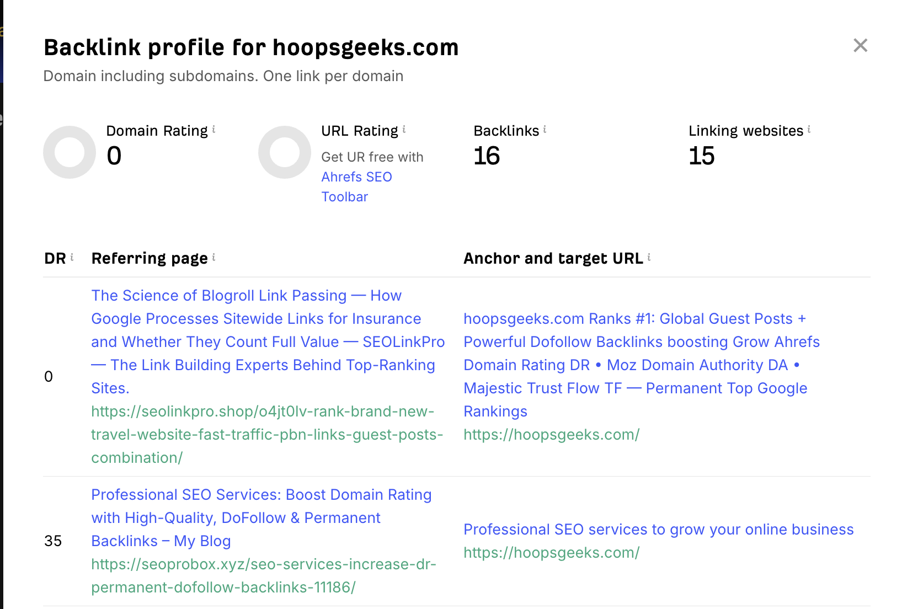
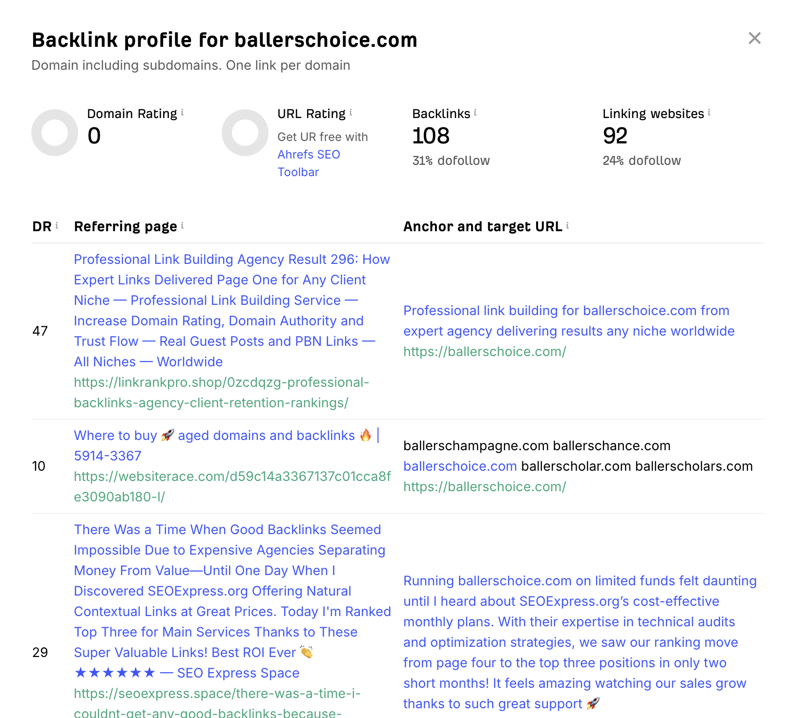

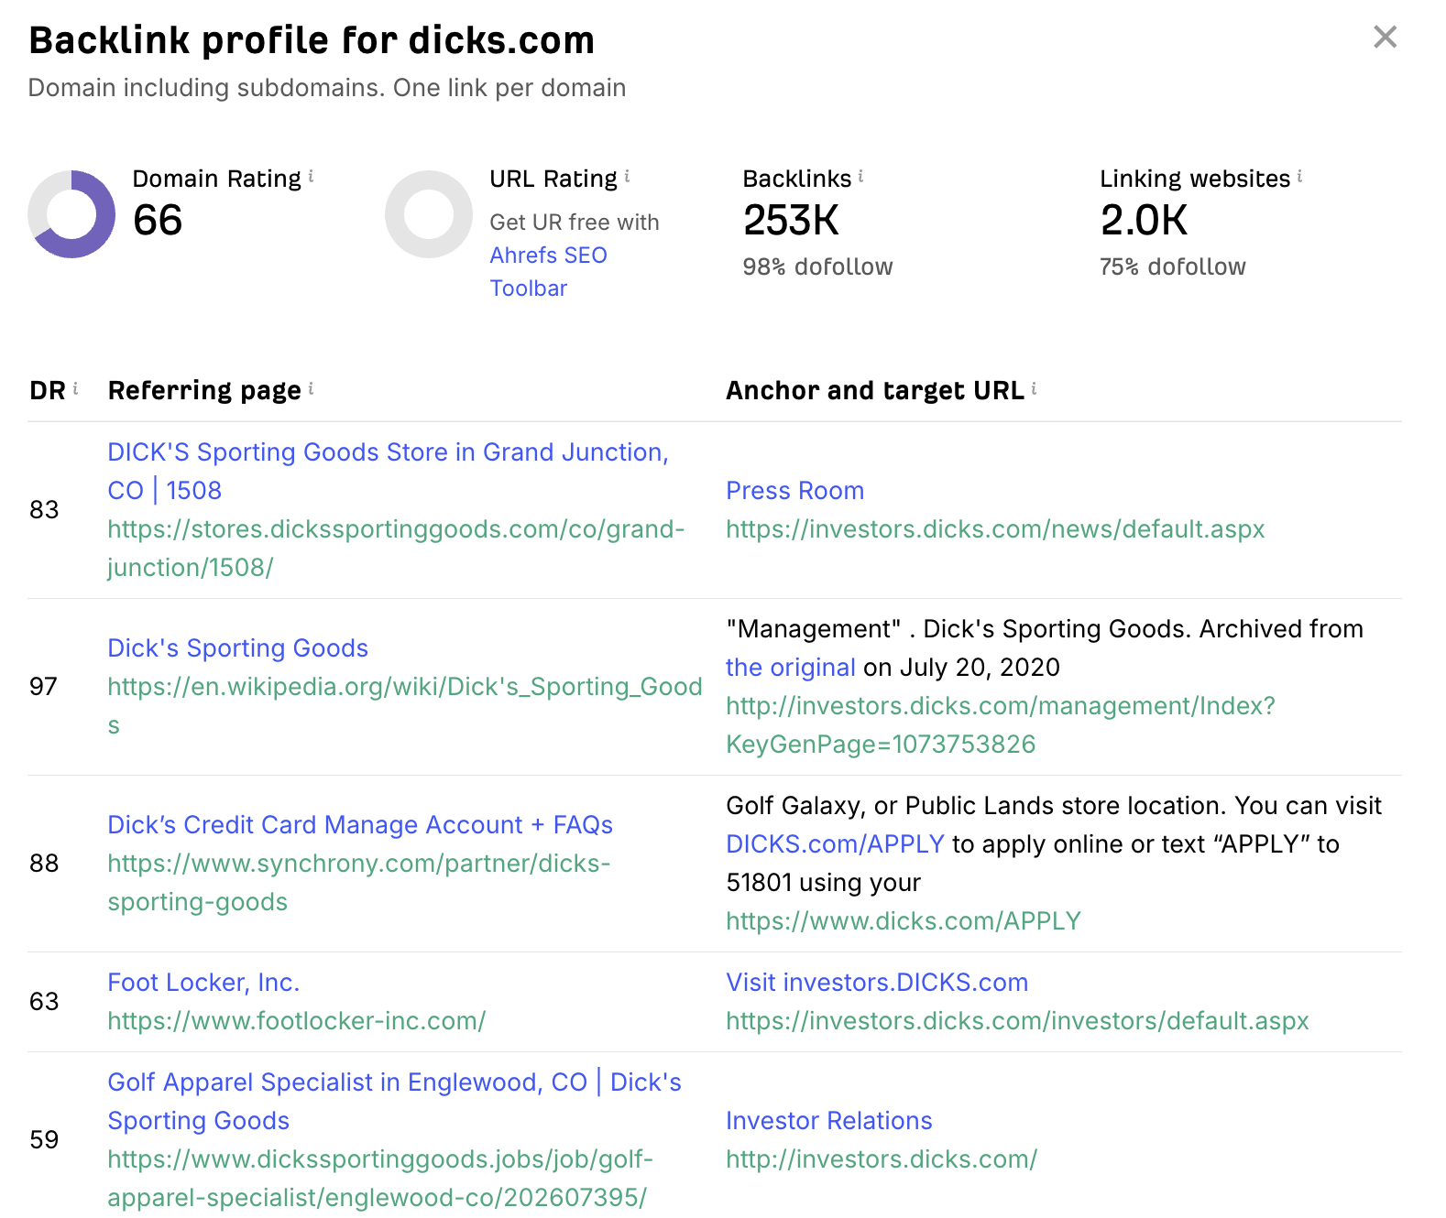

3. Strengths and Weaknesses Summary
The following is a consolidated breakdown from the full analysis:

Competitor | Key Strengths | Key Weaknesses
HoopsGeeks | Consistent content publishing, good DA, niche authority, strong forum backlinks | Broken links, incomplete meta tags, no video content, thin inner pages
BallerChoice | Long-tail keyword targeting in headings, some quality guest post backlinks | Duplicate content, slow mobile speed, weak content depth, low DA
Dick's Sporting Goods | Exceptional DA, technical SEO, schema markup, editorial backlinks, buying guides | Not basketball-specific, broad audience limits niche relevance

4. Identified Opportunities
The competitive analysis surfaces four clear areas where basketballstore.net can realistically outperform HoopsGeeks and BallerChoice:
Opportunity 1 — Low-Competition Long-Tail Keywords:
Neither direct competitor has optimised pages for terms like "youth basketball hoop kit", "outdoor basketball under $50", or "beginner basketball training kit". These have decent monthly search volume (5,000-8,000) and low keyword difficulty (under 35), making them realistic first-page ranking targets within 3-6 months of publishing focused content.
Opportunity 2 — Technical Advantage:
Both HoopsGeeks and BallerChoice have fixable but currently unaddressed technical problems (broken links, slow speed, duplicate content). By maintaining a clean, fast, technically sound website, basketballstore.net can gain ranking preference in competitive search positions where Google factors in Core Web Vitals.
Opportunity 3 — Short-Form Video and Social Content:
Neither competitor is consistently producing short-form video content. Building an Instagram Reels and YouTube Shorts channel around basketball tips, product unboxings, and skill tutorials would increase brand visibility and drive backlinks naturally as content gets shared.
Opportunity 4 — Beginner and Gift Buyer Content:
Neither competitor has a well-developed content hub targeting first-time basketball buyers or gift shoppers. These audiences convert well and use commercial-intent search phrases that are still underserved. Articles like "What to Buy a Basketball Fan" or "First Basketball Gear Checklist" target real demand without facing stiff competition.

5. Competitive Strategy

Phase 1 (Month 1-2): Technical Foundations
- Run a full technical audit on basketballstore.net and fix all crawl errors, broken links, and slow-loading pages
- Add missing meta descriptions to every page using primary keywords naturally
- Implement Product schema markup across all product pages
- Ensure mobile load time is under 2.5 seconds — compress images and enable caching

Phase 2 (Month 2-4): Content Build-Out
- Create five long-form (1,500+ words) category or guide pages targeting the keyword gaps identified in Step 5
- Launch a blog with a publishing schedule of two articles per week, focusing on beginner guides, gear comparisons, and seasonal content
- Optimise all product descriptions — minimum 200 words per product, include FAQ sections where relevant
- Build out internal linking clusters: every article should link to at least two relevant product pages

Phase 3 (Month 3-6): Off-Page and Social
- Begin outreach to basketball forums, niche sports blogs, and YouTube creators for guest posts and product mention opportunities
- Target the same referring domains that link to HoopsGeeks — offer more comprehensive resources or data they can reference
- Post three Instagram Reels per week and two YouTube Shorts per week featuring product demos and basketball tips
- Engage actively in basketball communities (Reddit, Twitter/X) to build brand familiarity and earn organic mentions

Phase 4 (Ongoing): Monitor and Refine
- Track all target keyword rankings weekly and compare against both direct competitors
- Review competitor backlink growth monthly and adjust outreach lists accordingly
- Conduct quarterly keyword gap refreshes to spot new opportunities as competitors evolve their strategies
- Analyse organic traffic and conversion data monthly — double down on content types that drive sales

6. Monitor and Iterate
Competitive SEO is an ongoing process. The strategies outlined above will be reviewed and refined continuously based on performance data. Key monitoring checkpoints include:
- Weekly keyword ranking reviews using Ubersuggest Rank Tracker
- Monthly site audit to maintain technical health score above 85/100
- Quarterly backlink profile comparison against HoopsGeeks and BallerChoice
- Monthly review of social media engagement metrics and top-performing content formats
Search algorithm updates, seasonal demand shifts, and competitor activity will all influence the optimal approach. The commitment to consistent content production and technical maintenance is the most durable competitive advantage available to a niche e-commerce store operating in this space.

